Mushrooms on the Super Bowl snack line? Yes, deliciously so!
- Buffalo Chicken and Kale Stuffed Mushrooms -
By: Melissa d’Arabian January 5, 2015

Anybody who has kids will appreciate this milestone. My daughter ate an entire mushroom for the first time the other day!

I had roasted it on a baking sheet alongside other veggies, knowing she would likely skip the mushroom and dig around for the carrots and beets instead. Up until the other night, she had always shied away from these earthy little morsels. But apparently now, at the ripe age of 7, she is on the mushroom bandwagon, and I am thrilled.

I love mushrooms because they are meaty and satisfying, yet an entire cup has just 15 tiny calories (and 2 grams of protein). Plus, they offer a dose of antioxidants, vitamins, minerals and dietary fiber.

But the real benefit is that the deep flavor of mushrooms will make you completely forget you are eating something healthy. Looking for a veggie that won't leave you feeling hungry? The mushroom is your guy.

And the perfect time to forget your food is actually healthy is the tailgate party. Football season is snacking season. The only problem with game-time snacking - especially for the Super Bowl - is that we can easily get stuck in a Buffalo wing rut, which is not an excellent long-term major snacking strategy for the health-conscious.

So this weekend I couldn't help but be inspired by Margaux's new-found love of mushrooms. I took all the flavors of a Buffalo wing and stuffed them into a mushroom cap, then baked it. The filling and bulky mushroom slowed down my snacking enough to keep me from overdoing it on the cheesy, spicy goodness. Just in case I happen to get caught up in the game...

BUFFALO CHICKEN AND KALE STUFFED MUSHROOMS
Start to finish: 45 minutes Makes 15 mushrooms

Two 10-ounce packages medium white button, baby bella or cremini mushrooms, stemmed
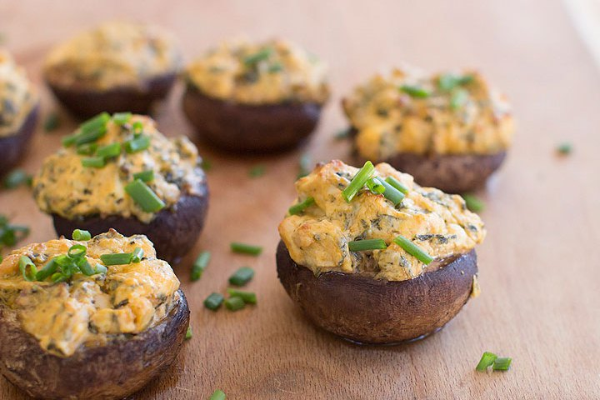
Kosher salt and ground black pepper
1 tablespoon butter
1 shallot, minced
3 cloves garlic, minced
1/2 bunch kale, stems removed, finely chopped (about 1 cup)
1 tablespoon lemon juice
3/4 cup chopped cooked chicken
8 ounces light cream cheese, softened
1/4 cup hot sauce, such as Frank's
1/4 cup blue cheese crumbles
Olive oil cooking spray

Heat the oven to 375 F. Line a rimmed baking sheet with foil or kitchen parchment, then mist with olive oil cooking spray.

Use a damp paper towel to wipe the mushroom caps clean, then season them with salt and pepper. Set aside.

In a medium saute pan over medium heat, melt the butter. Add the shallot and garlic and saute until soft, about 3 minutes. Add the kale and saute until wilted. Add the lemon juice, cover and allow to steam for 1 to 2 minutes. Uncover, remove the pan from heat and stir in the chicken.

In a small bowl, mix together the cream cheese, hot sauce and blue cheese crumbles. Add the kale and chicken mixture to the cream cheese mixture and mix well. Spoon the cheese filling into the mushroom caps, then arrange the filled caps on the prepared baking sheet. Mist the tops lightly with olive oil cooking spray, then bake for 25 minutes, or until tops are golden and mushrooms are tender.

Nutrition information per mushroom: 80 calories; 45 calories from fat (56 percent of total calories); 5 g fat (3 g saturated; 0 g trans fats); 25 mg cholesterol; 3 g carbohydrate; 1 g fiber; 1 g sugar; 6 g protein; 250 mg sodium.

Food Network star Melissa d'Arabian is an expert on healthy eating on a budget. She is the author of the "Supermarket Healthy" cookbook. http://www.melissadarabian.net

